This agency is using Ontario Common Assessment of Need (OCAN) to understand your needs. This formal process is becoming standard across the province to ensure that your health workers focus on your identified needs.
Welcome to this opportunity to have your own voice heard

OCAN consists of two parts, a self-assessment completed by you and an assessment completed with you and your worker.

The self-assessment is optional and starts the conversation with your worker to complete and inform OCAN.

We would like you to participate in using OCAN and here’s why:

- OCAN questions are commonly used by many community mental health agencies. If you choose to share this information with another agency, it may reduce the number of times you have to answer the same questions.

- Agencies can work with you to better find the right help the first time because it asks a broad set of questions that identifies your needs in different life areas.
- You can fully discuss your needs. The answers you give will help identify what services you need and which goals to work on first.

- You can record your comments in every section, as well as your hopes, dreams and goals so that a plan can be developed to help you get there.

It’s your choice

Remember:

  - Information collected using the self-assessment represents your view of where you are today.

  - You will still receive service from this agency whether or not you choose to do it.

  - You decide how and when your information is used and shared with others.

  - Sharing that information can facilitate a more collaborative effort in planning the services you need.

  - Ask about your legal rights under the Personal Health Information Protection Act (PHIPA) 2004

With OCAN, you decide how many of the questions you answer and the amount of time you need to complete it. You can also say you don’t want to answer some or all of the questions.

How will my answers be used?

Your answers to the questions in OCAN will be used to help identify the support you need. Unless you tell us not to, this information may be shared with other agencies.

If you say “no” to sharing the information you can change your mind later on.

Welcome to a new way to have your say.

This is your opportunity to take an active part in your assessment and have your views heard.

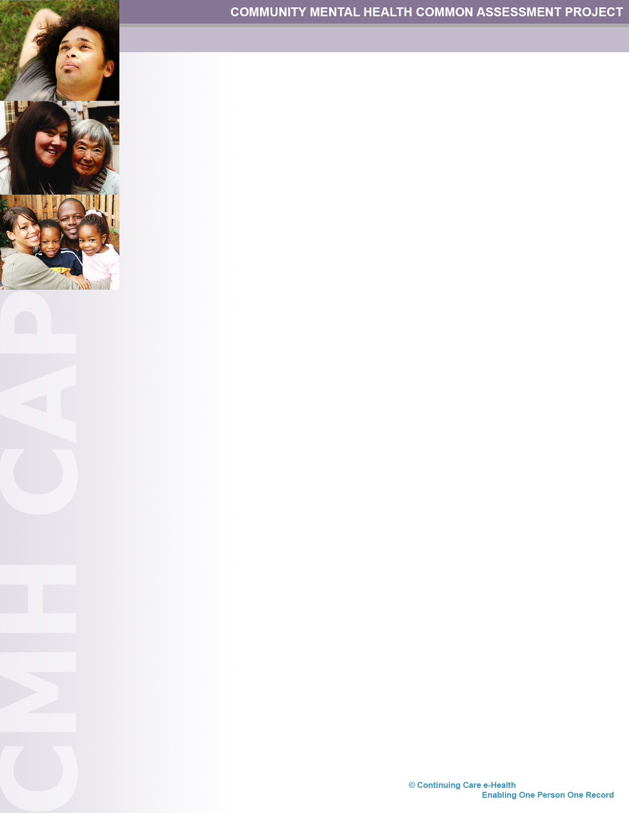
Your invitation as a consumer of mental health services to have your needs known

OCAN
(Ontario Common Assessment of Need)

If we are unable to resolve your concerns about how your personal health information has been handled, you may wish to contact the Information and Privacy Commissioner of Ontario at:

2 Bloor Street East, Suite 1400
Toronto, ON M4W 1A8
Telephone: 416 326 3333 or 1 800 387 0073
www.ipc.on.ca

